Assignment 4 Basic Knowledge

**Task 1** 4 LEDs are connected to Arduino Uno, try to use LCD1602 to display the current state of LED been lighted.

任务1 使用3个LED连接至Arduino Uno，使用LCD1602 显示当前小灯点亮的状态，（1s位移）。

**You could use Tinker CAD or Proteus for the verifying.可使用在线工具Tinker CAD或Proteus进行仿真。**

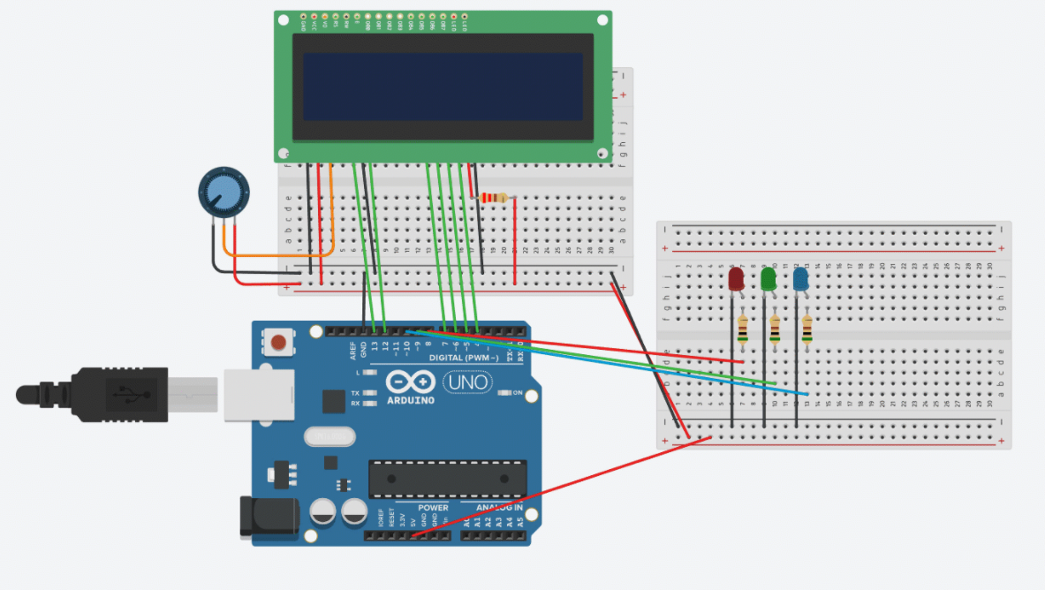

#include<LiquidCrystal.h>  
LiquidCrystal lcd(13,12,7,6,5,4);  
  
String ledColor[3]={"Red","Green","Blue"};  
  
void setup(){  
  Serial.begin(9600);  
  pinMode(8,OUTPUT);  
  pinMode(9,OUTPUT);  
  pinMode(10,OUTPUT);  
  lcd.begin(16,2);  
}  
void loop(){  
    
  for(int i=8;i<11;i++)  
  {  
    int ledNo=i;  
    digitalWrite(i,HIGH);  
    lcd.setCursor(0,0);  
    lcd.print("Current LED is:");  
    delay(10);  
    lcd.setCursor(3,1);  
    lcd.print(ledColor[ledNo-8]);  
    delay(1000);  
    digitalWrite(i,LOW);  
  }  
  }